Luke 12:41-48
New International Version (NIV)
⁴¹ Peter asked, “Lord, are you telling this parable to us, or to everyone?”
⁴² The Lord answered, “Who then is the faithful and wise manager, whom the master puts in charge of his servants to give them their food allowance at the proper time? ⁴³ It will be good for that servant whom the master finds doing so when he returns. ⁴⁴ Truly I tell you, he will put him in charge of all his possessions. ⁴⁵ But suppose the servant says to himself, ‘My master is taking a long time in coming,’ and he then begins to beat the other servants, both men and women, and to eat and drink and get drunk. ⁴⁶ The master of that servant will come on a day when he does not expect him and at an hour he is not aware of. He will cut him to pieces and assign him a place with the unbelievers.
⁴⁷ “The servant who knows the master’s will and does not get ready or does not do what the master wants will be beaten with many blows. ⁴⁸ But the one who does not know and does things deserving punishment will be beaten with few blows. From everyone who has been given much, much will be demanded; and from the one who has been entrusted with much, much more will be asked.
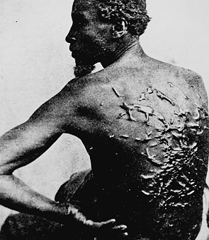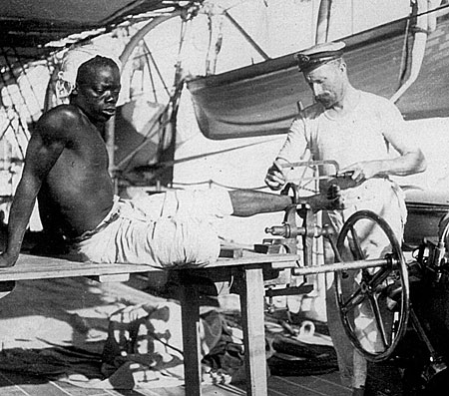
1. Find these images. [search ‘slave photographs’ on google]
2. Cite these images properly using the OWL website.
3. Read the passage from Luke, properly cite the reference using the OWL website.
4. How could you use the passage and the image to support your research paper?

