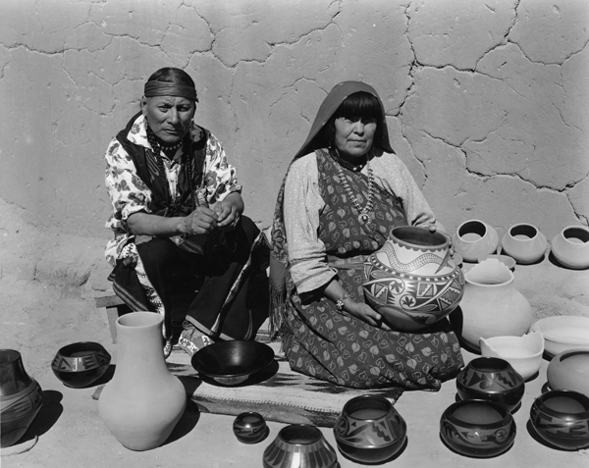
Write your name here: _______________________________________

Maria Martinez and friend (and pottery) have something to say related to artwork produced in New Mexico during the Great Depression. They need to say something about specific themes, styles and focus on the artists.

