Name: _______________________________ Date: _______________ IN Class assignment 20pts.
1. A story can be said to be broken down in to these parts:
Exposition, Rising Action, Climax, Falling Action and Denouement.
Provide written examples of each of these parts shown in The Lady With the Dog.
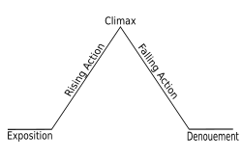

2. Choose a question to answer from one of the categories on the board and develop a thesis about this category. Answer this question on lined paper and attach it to this sheet. Your answer should be a page long. Take notes from the board on this page. Write those notes down here.

