20 points – Class research on the role of New Mexico in WWII
New Mexico played an important role in WWII. Our involvement included the following contributions to securing our place in history and helping to end the war:
- Navajo Code Talkers
- New Mexico National Guard
- Bataan Death March
- Internment Camps
- Manhattan Project
Each one of these areas of contribution helped place New Mexico on the map.
Choose a particular subject and research an individual who was directly impacted by these historic events and the history of New Mexico.
For example: If you chose the Manhattan project, research how this had an impact on New Mexico (jobs, science, the creation of a centralized military, etc) and pair this with Robert Oppenheimer who came to Los Alamos Ranch School as a youth to recover from an illness, eventually leading the Manhattan project and presiding over the first test of an atomic bomb.
1. Short written description (60 words) of the subject and the individual – grammatically correct, etc.
2. Two pictures (one of the subject and one of the individual).
3. Print out /email your copy by the end of class.
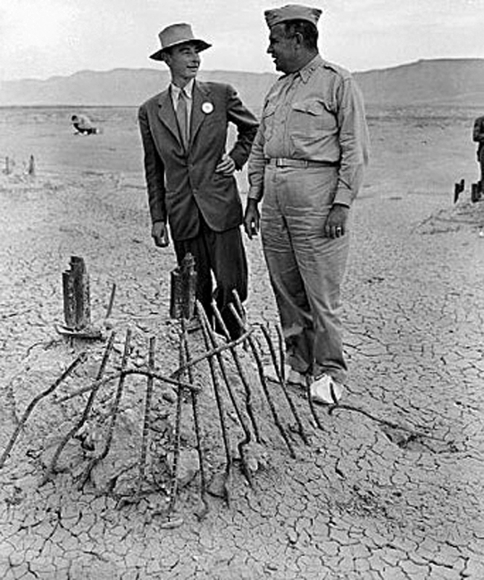
The Manhattan Project and New Mexico. 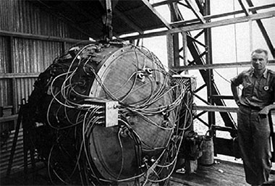
If you chose the Manhattan project, research how this had an impact on New Mexico (jobs, science, the creation of a centralized military, etc) and pair this with Robert Oppenheimer who came to Los Alamos Ranch School as a youth to recover from an illness, eventually leading the Manhattan project and presiding over the first test of an atomic bomb.

