Short Magical Realism Story.  Work on draft/outline in class Oct. 27/28. Final version will be due October 20/30. You final must type this. 12 pt. Times New Roman.  50 Points | A –The paper is typed with examples from each of the columns on the left. Has a sense of true short story. No mistakes. The story has a well-defined plot. Strong exposition, conflict, rising action, climax, falling action and resolution. | B – Has the basic elements. Is typed. Few grammatical errors. Has topic sentences, details and concluding sentences. The story has a plot. Strong exposition, conflict, rising action, climax, falling action and resolution | C – Some grammatical errors. Few elements, undeveloped plot, characters, setting, etc. The story has a weak plot. Strong exposition, conflict, rising action, climax, falling action and resolution | D – Did not follow rubric, many grammatical errors. Seems rushed and written without care or thought of the assignment. The story does not have a plot. Strong exposition, conflict, rising action, climax, falling action and resolution
Contains fantastical elements. (winged angels who look like sailors, giant corpses).
Exhibits a richness of sensory details (the five senses: hear, taste, smell, touch sight).
Uses symbols and imagery extensively. Have a repeating symbol.
The setting is distorted by the end of the story. A change or transformation takes place.
Incorporates legend or folklore into the story. This can be something you make up. Or a previously unknown myth.
Diagram the plot of the story:
Exposition, conflict, rising action, climax, falling action, resolution.
Exposition: Introduction of background information.
Conflict: a struggle between two people or things in the story.
Rising Action: Ingredients that complicate the plot.
Climax: The turning point in the story.
Falling Action: The part of the story after the climax.
Resolution: What you learn about the characters at the end of the story.

You will be writing your own magical realism story. Before you begin, review the rubric. You will be working on a draft in class and the final copy will be indicated on the dates in the rubric.
1. What fantastical elements will you include in your story: __________________________________________________________________________________________________________________________________________________________________________________________________________________________________________
2. What particular senses will you be using in your story? Smell, Sight? __________________________________________________________________________________________________________________________________________________________________________________________________________________________________________
3. A good story has a strong use of symbols that are often repeated. List them and explain how they will be used. ________________________________________________________________________________________________________________________________________________________________________________________________________________________________________________________________________________________________________________________
4. What legends or folklore will you be using in this story. Will you be creating any legends or myths? What are they?___________________________________________________________________________________________________________________________________________________________________________________________________________________________________________________________________________________________________________________
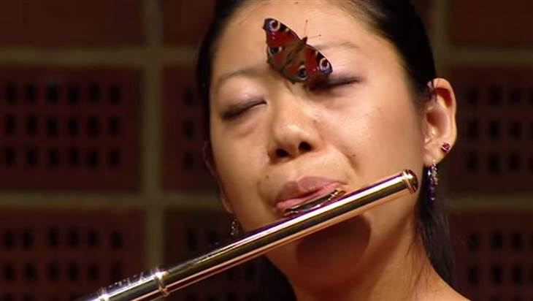 You see this woman playing the flute. This seems like a commonplace event except for the “inconvenience” of the butterfly! I could see an image like this one being turned into a magical realism story. Before you start such a story have a visual image in your mind, develop the plot structure and make sure your story is meaningful.
Name: __________________________________________________________
Turn this in with your draft and final copy.

