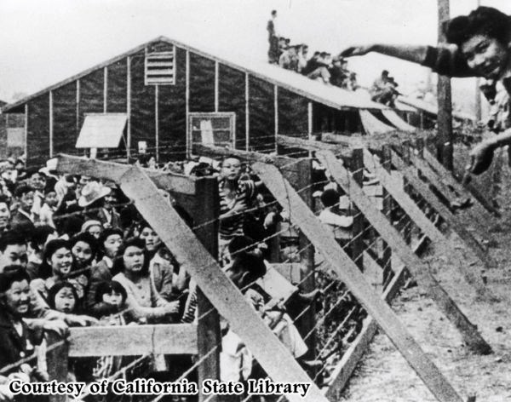
Name:
Date:
Class:
Pictures, and especially photographs, carry with them implicit narratives, or stories that can be told about the image. What specifically about this image from a Japanese Internment camp provides you with the basis for a good story? What is the story about this photo?
____________________________________________________________________________________________________________________________________________________________________________________________________________________________________________________________________________________________________________________________________________________________________________________________________________________________________________________________________________________________________________________________________________________________________________________________________________________________________________________________________________________________________________________________________________________________________________________________________________________________________________________________________________________________________________________________________________________________________________________________________________________________________________________________
[use the entire space to write about this image]

