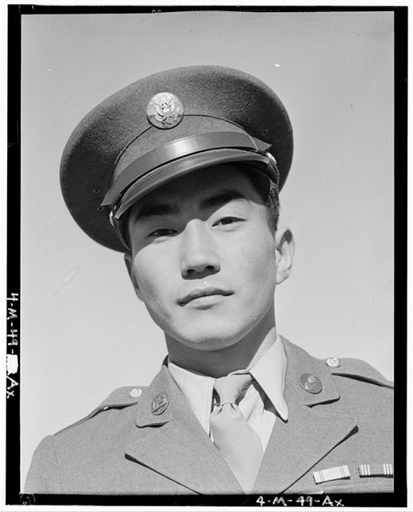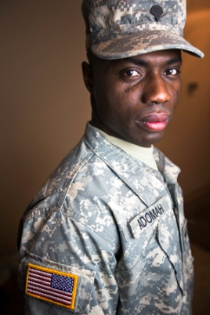
Name: _________________
Class: _________________
Date: __________________
How does the article from the New York Times “U.S. Military will offer Path to Citizenship” compare/contrast to the Loyalty Oath given to Japanese-Americans during WWII? Use your “Transitional Words and Phrases to answer the question. When writing, use 6 [six] transitional words/phrases to write clarify your answer. [Underline your transitional phrases]
________________________________________________________________________________________________________________________________________________________________________________________________________________________________________________________________________________________________________________________________________________________________________________________________________________________________________________________________________________________________________________________________________________________________________________________________________________________________________________________________________________________________________________________________________________________________________________________________________________________________________________________________________________________________________________________________________________________________________________________________________________________________________________________________________________________________________________________________________________________________________________________________________________________________________________________________________________________________________________________________________________________________________________________________________________________________________________________________________________________________________________________________________________________________________________________________________________________________________________________________________________________________________________________________________________________________________________________________________________________________________________________________________________________________________________________________________________________________________________________________________________________________________________________________________________________________________________________________________________________________________________________________________________________________________________________________________________________________________________________________________________________________________________________________________________________________________________________________________________________________________________________________________________________________________________________________________________________________________________________________________________________________

