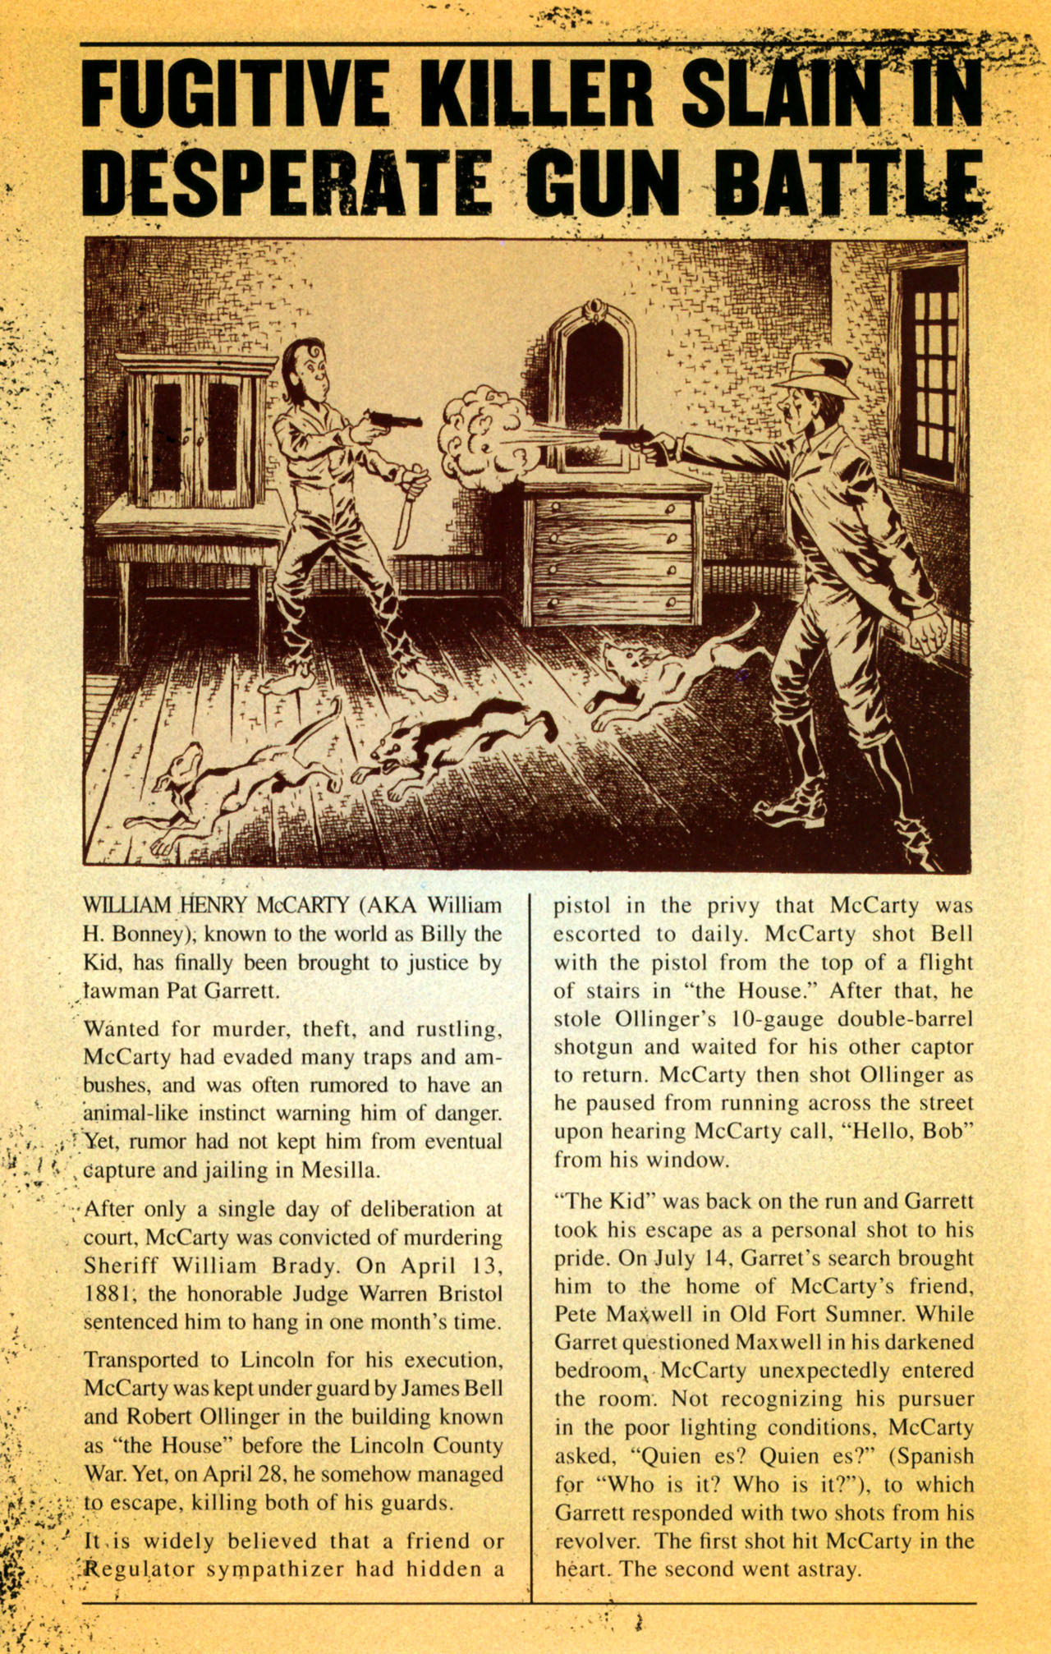
Billy the Kid Newspaper article.
The notorious outlaw has met his final dispatch. You are required to inform readers far and wide of this deadly killers misdeeds and tell them how the Lincoln County War began and ended.
Provide details about a few of the following reasons for the War:
- Economic reasons and competition between the Big Store and Tunstall/McSween/Chisum.
- Involvement of the Santa Fe Ring
- Billy the Kid/William H.Bonney/Henry Antrim (all the same man!)
- The Five Days Battle
- Pat Garrett encounter with Billy

Your article should be at least 250 words long and contain hyperbolic language (colorful, exaggerations designed to impress readers), facts about the Lincoln County War, specific dates, etc.
_______________ Spelling and grammar 10 points
_______________ Newspaper language. 10 points
_______________ 250 words 10 points
_______________ Appropriate use of facts and figures.
Total __________/40

