Asian Comix – Final Pages. When you have finished, please print out your comix. Make sure your name is on the document.
You have already completed a profile of Li Bai and Du Fu to include: 1. Historical background information about the poets to include their place of birth, significant events, life, early years, Tang Dynasty, etc. 2. Images of both poets. 3. Translated copies of one poem from each poet. 4. Analysis of these poems. 5. An interesting quote about the poet.
You need to add additional pages to include the following:
Create a dialog between Li Bai and Du Fu concerning their poems and poetry. Both were different poets, with consistently different themes.
Birds?? Birds are nature. Very Tao. Have you read my poem, Two Golden Oriels Sing? You and your moon – you are a drunken fool!
Hey, Du Fu, why are you always writing about birds?

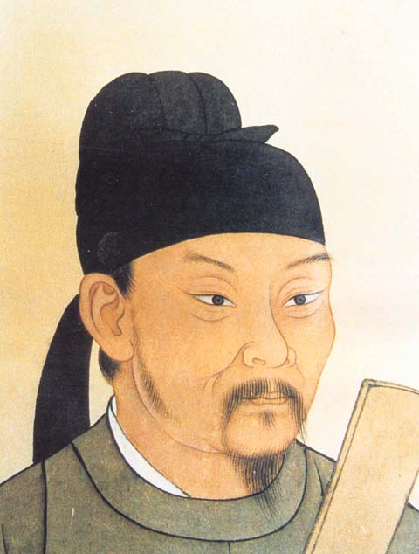

Two golden orioles sing in the green willows,
A row of white egrets against the blue sky.
The window frames the western hills' snow of a thousand autumns,
At the door is moored, from eastern Wu, a boat of ten thousand li.
MAKE A COVER PAGE!!!
Print your final copy on the color printer when you are done.
Name: _______________________ Date: _______

