Autumn Air
Li Bai
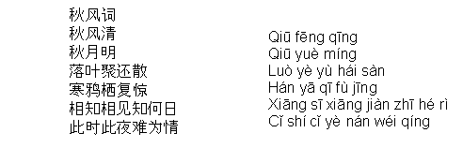
Autumn wind clear  Autumn moon bright  Fall leaves gather and scatter  Jackdaw perch again startle  Each think each see know what day  This hour this night hard be feeling | The autumn air is clear,  The autumn moon is bright.  Fallen leaves gather and scatter,  The jackdaw perches and starts anew.  We think of each other- when will we meet?  This hour, this night, my feelings are hard.
